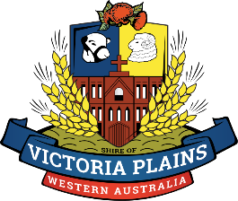

SHIRE OF VICTORIA PLAINS LOCAL HeriTAge SURVEY 2023
NOMINATION FORM
Places are listed in the Shire of Victoria Plains Local Heritage Survey on the basis of the assessment of the cultural heritage significance relevant to the Shire of Victoria Plains.
Calling for nominations is a part of the process of community consultation that will also include a public forum. A Heritage Consultant has been engaged by the Shire to re-assess places already listed, and any further nominations from the community, before recommendations are made to Council.
Your details
Name………………………………………………………………………………………….………………
Address……………………………………………………………………………………………………….
Contact phone & email …………………………………………………………………………………….
Nominated place
Name…………………………………………………………………………………………………………
Address………………………………………………………………………………………………………
Directions if out of town………………………………………………………………………………….…
Is it publically accessible……………………..Is it occupied………………………………………….…
Owners name, address & contact if known……………………………………………………………...
DETAILS of the PLACE Just provide as much as you know
Date of construction………………Changes to the place……………………………….………….…..
Original use……………………… Original owner or associations ………………………...…………
Description of the place…………………………………………………………………………………….
History of the place
……………………………………………………………………………………………………………….
……………………………………………………………………………………………………………….
……………………………………………………………………………………………………………….
Why Do YOU think the place is of heritage significance ?
……………………………………………………………………………………………………………….
……………………………………………………………………………………………………………….
References………………………………………………………………………………………
Please submit Nomination forms and any supporting documents to the Shire of Victoria Plains by Friday March 17th.

